**Exercises**

1.    Install and make yourself familiar with **Microsoft Visual Studio** and Microsoft Developer Network (**MSDN**) Library Documentation.

2.    Find the description of the **System.Console** class in the standard .NET API documentation (MSDN Library).

3.    Find the description of the **System.Console.WriteLine()** method and its different possible parameters in the MSDN Library.

4.    **Compile and execute** the sample program from this chapter using the command prompt (the console) and Visual Studio.

5.    **Modify** the sample program to print a different greeting, for example "Good Day!".

using System;

namespace detyra6

{

class Program

{

static void Main(string[] args)

{

Console.WriteLine("Good Day!");

}

}

}

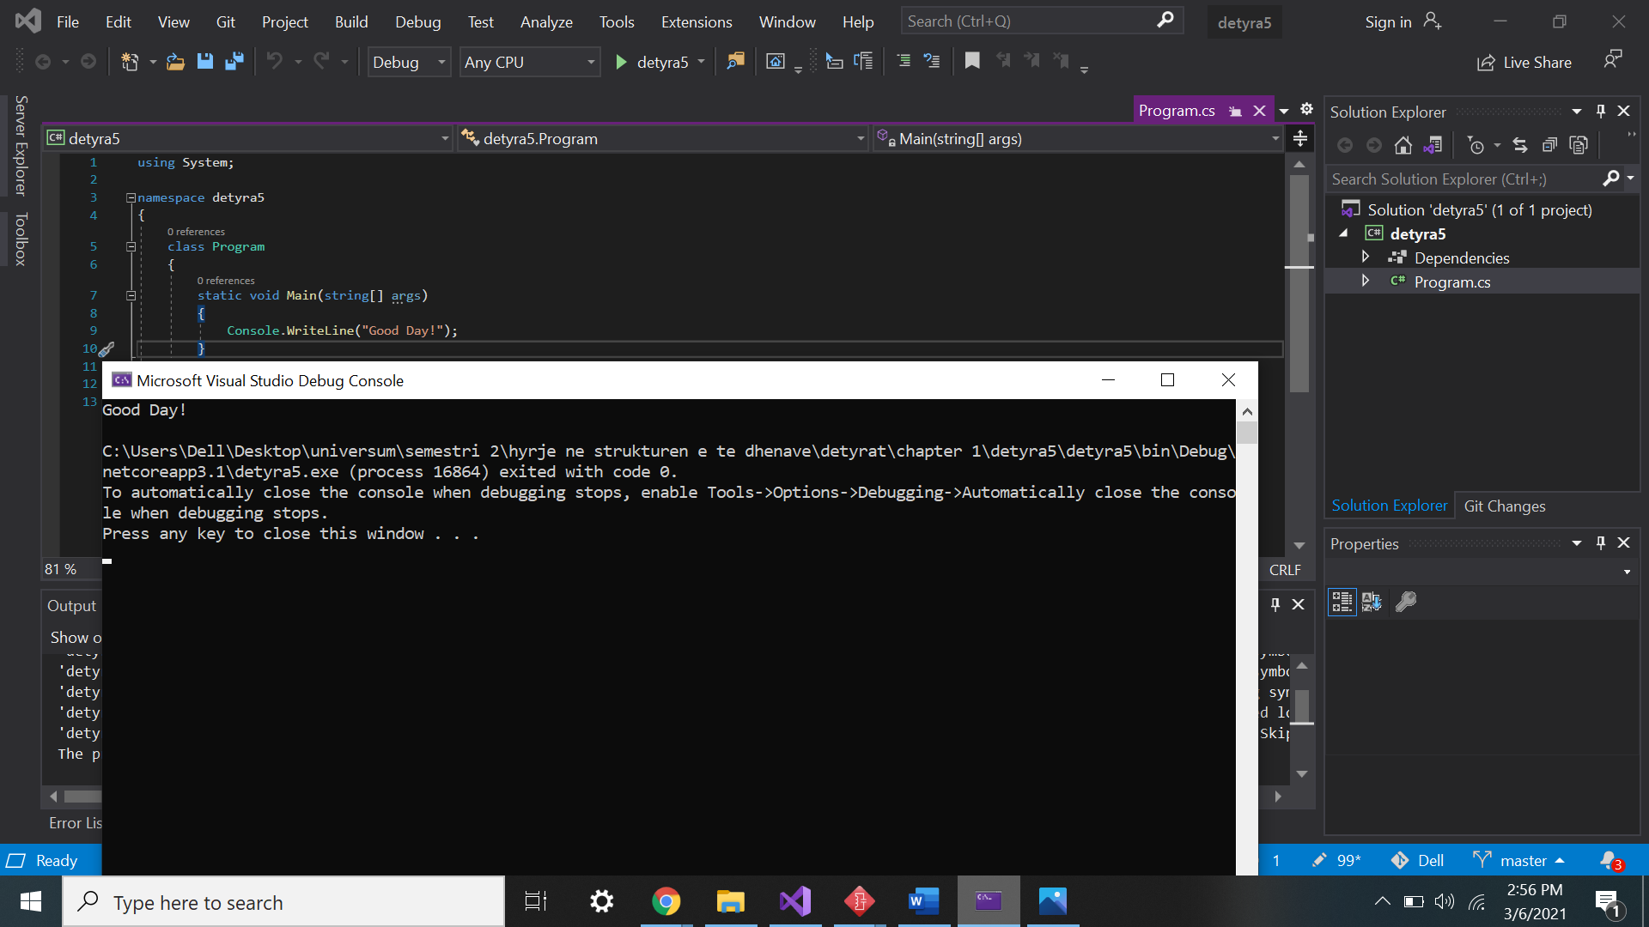

6.    Write a console application that **prints your first and last name** on the console.

using System;

namespace detyra6

{

class Program

{

static void Main(string[] args)

{

Console.WriteLine("Mehreme Gashi");

}

}

}

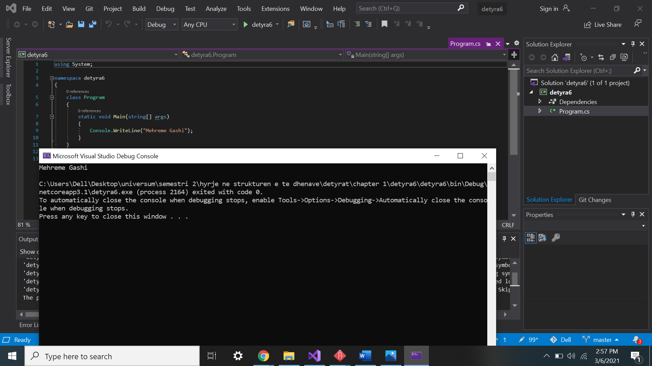

7.    Write a program that **prints the following numbers** on the console 1, 101, 1001, each on a new line.

using System;

namespace detyra7

{

class Program

{

static void Main(string[] args)

{

Console.WriteLine("1");

Console.WriteLine("101");

Console.WriteLine("1001");

}

}

}

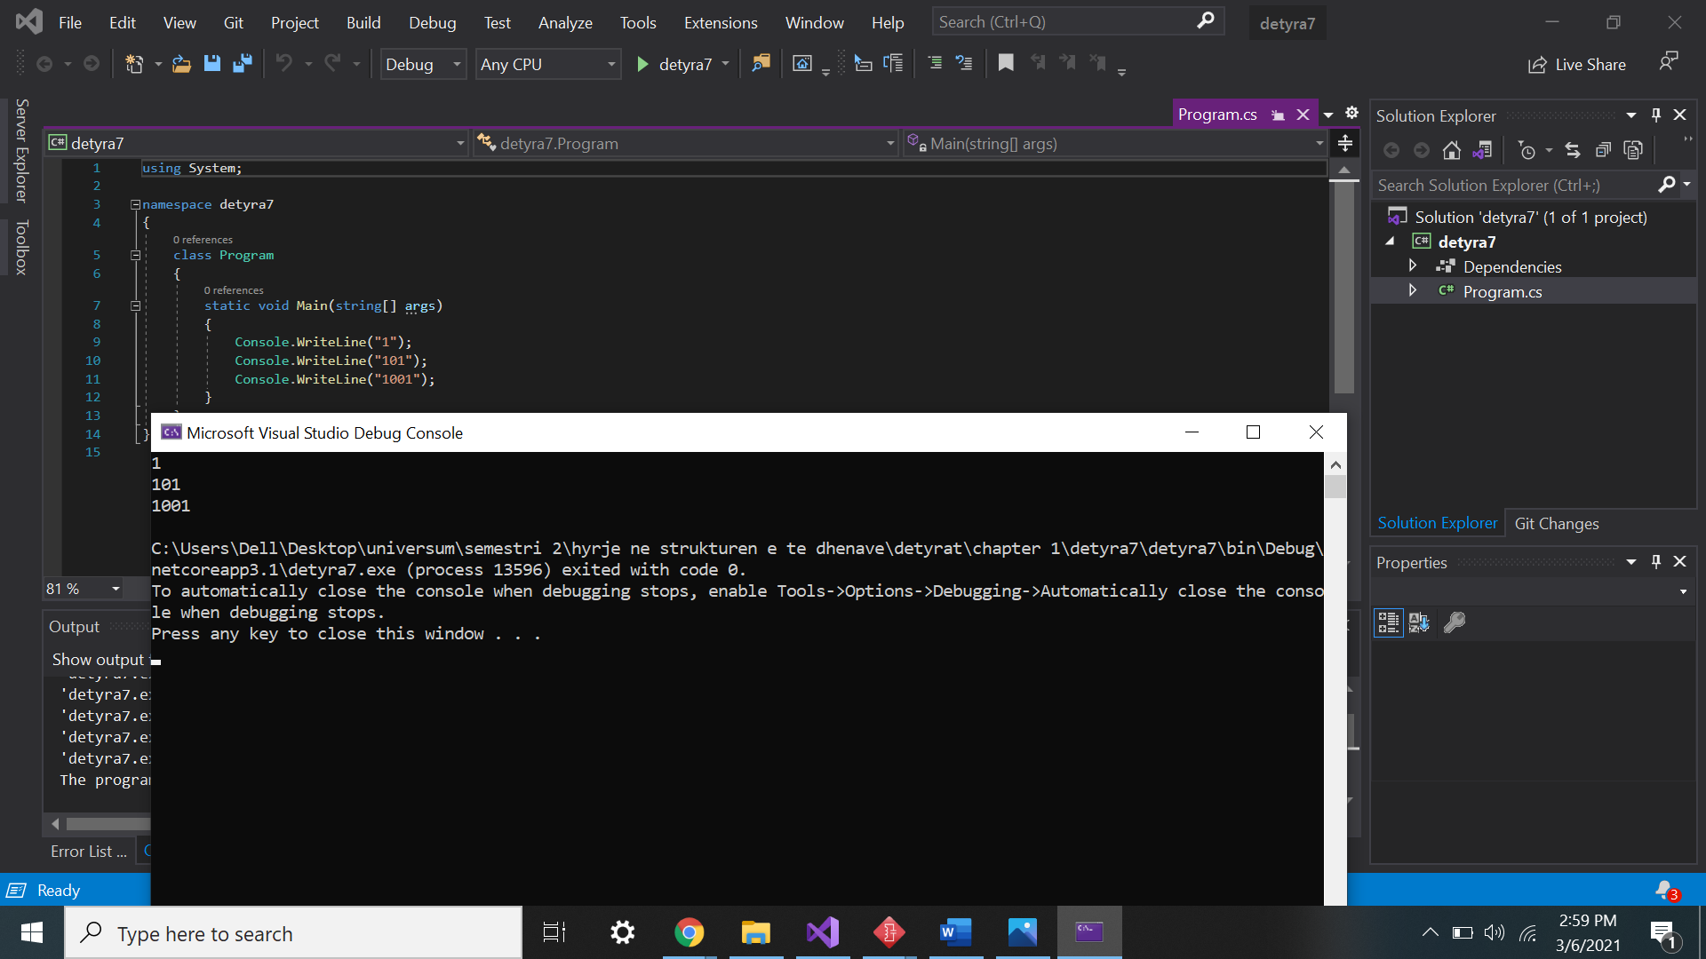

8.    Write a program that prints on the console the **current date and time**.

using System;

namespace detyra8

{

class Program

{

static void Main(string[] args)

{

string date = DateTime.UtcNow.ToString("D");

string time = DateTime.UtcNow.ToString("T");

Console.WriteLine(date + " " + time);

}

}

}

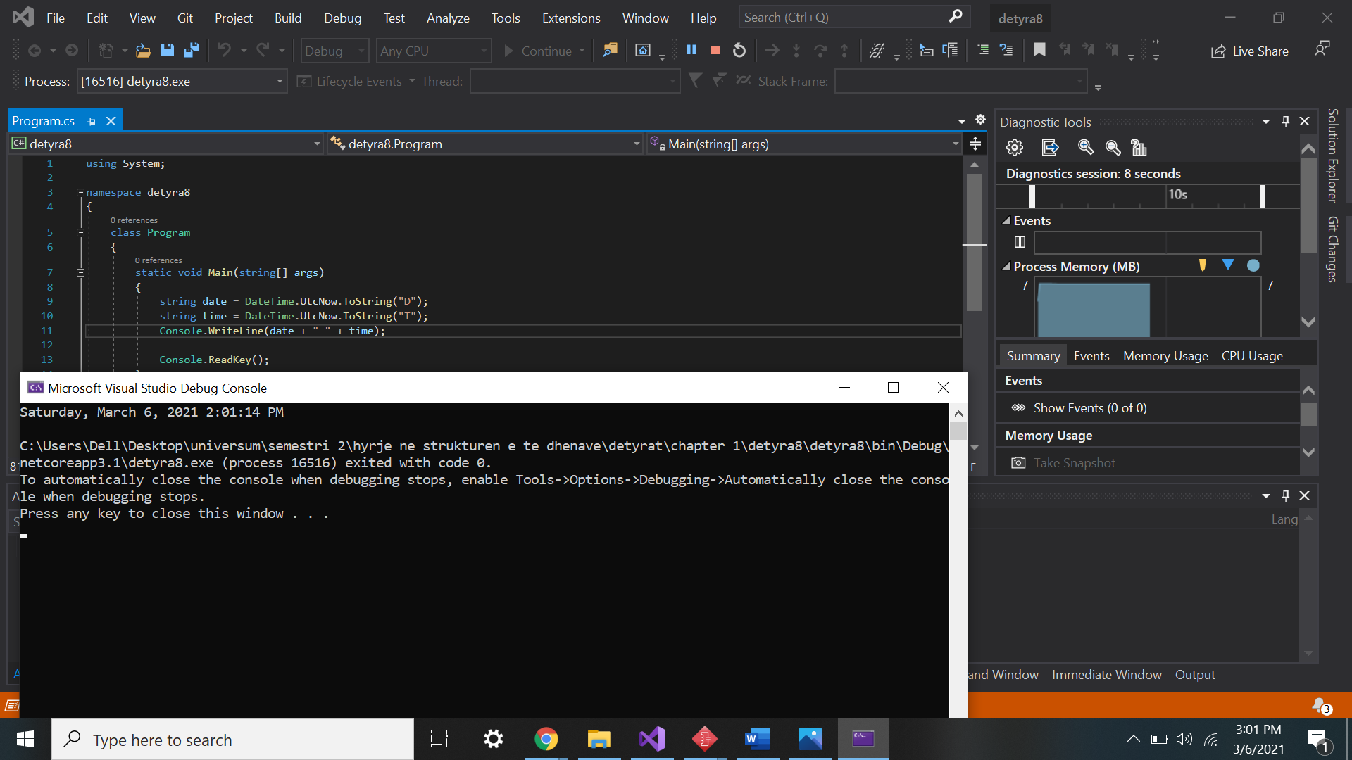

9.    Write a program that prints the **square root of 12345**.

using System;

namespace detyra9

{

class Program

{

static void Main(string[] args)

{

Console.WriteLine("Enter a number:");

int numberInt = Convert.ToInt32(Console.ReadLine());

Console.WriteLine($"Square root of {numberInt} is " + Math.Sqrt(numberInt));

}

}

}

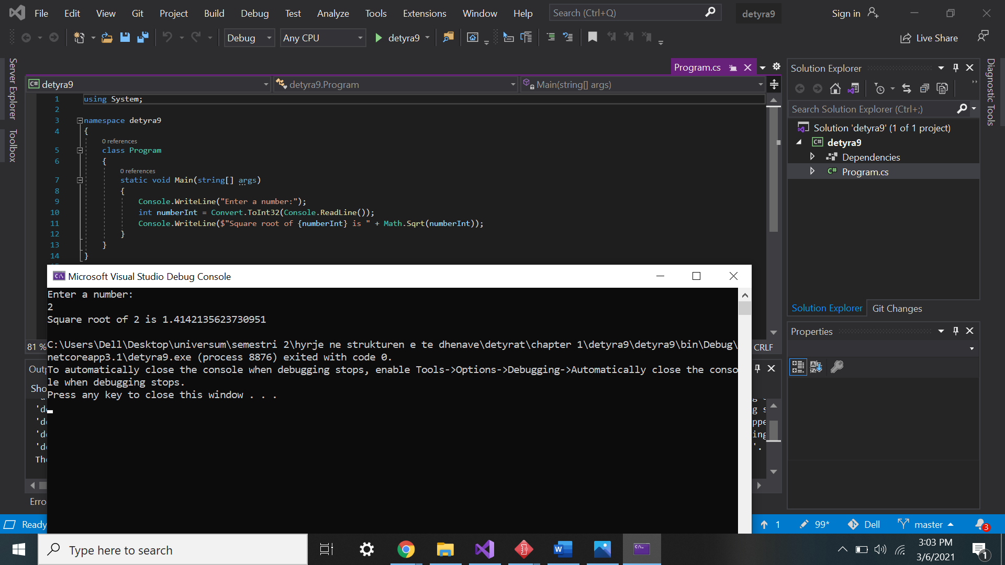

10.   Write a program that prints the first 100 members of the **sequence** 2, -3, 4, -5, 6, -7, 8.

using System;

namespace detyra10

{

class Program

{

static void Main(string[] args)

{

for (int i =1; i <= 100; i++)

{

if (i % 2 != 0)

{

Console.WriteLine(-i);

}

else

{

Console.WriteLine(i);

}

}

}

}

}

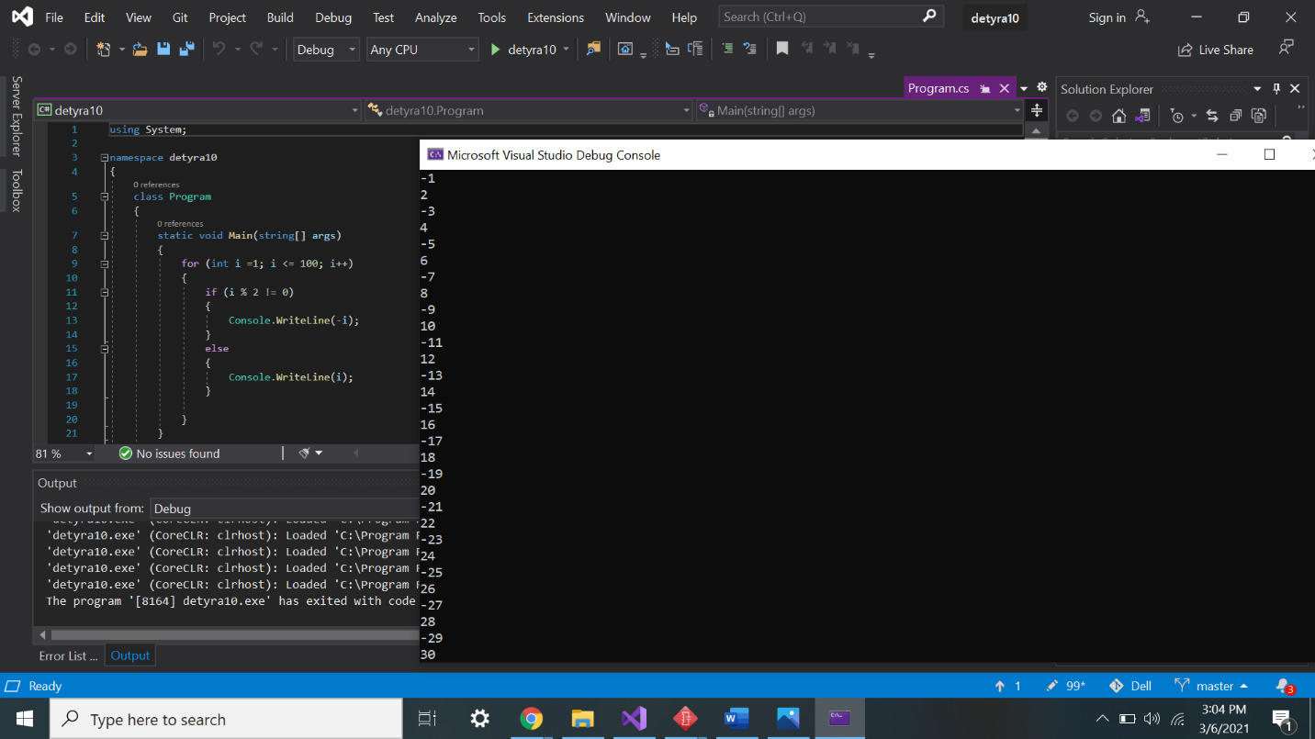

11.   Write a program that reads your age from the console and prints your **age after 10 years**.

using System;

namespace detyra11

{

class Program

{

static void Main(string[] args)

{

Console.WriteLine("Enter your age:");

string age = Console.ReadLine();

int ageToInt = Convert.ToInt32(age);

Console.WriteLine("After 10 years you will be " + (ageToInt + 10));

}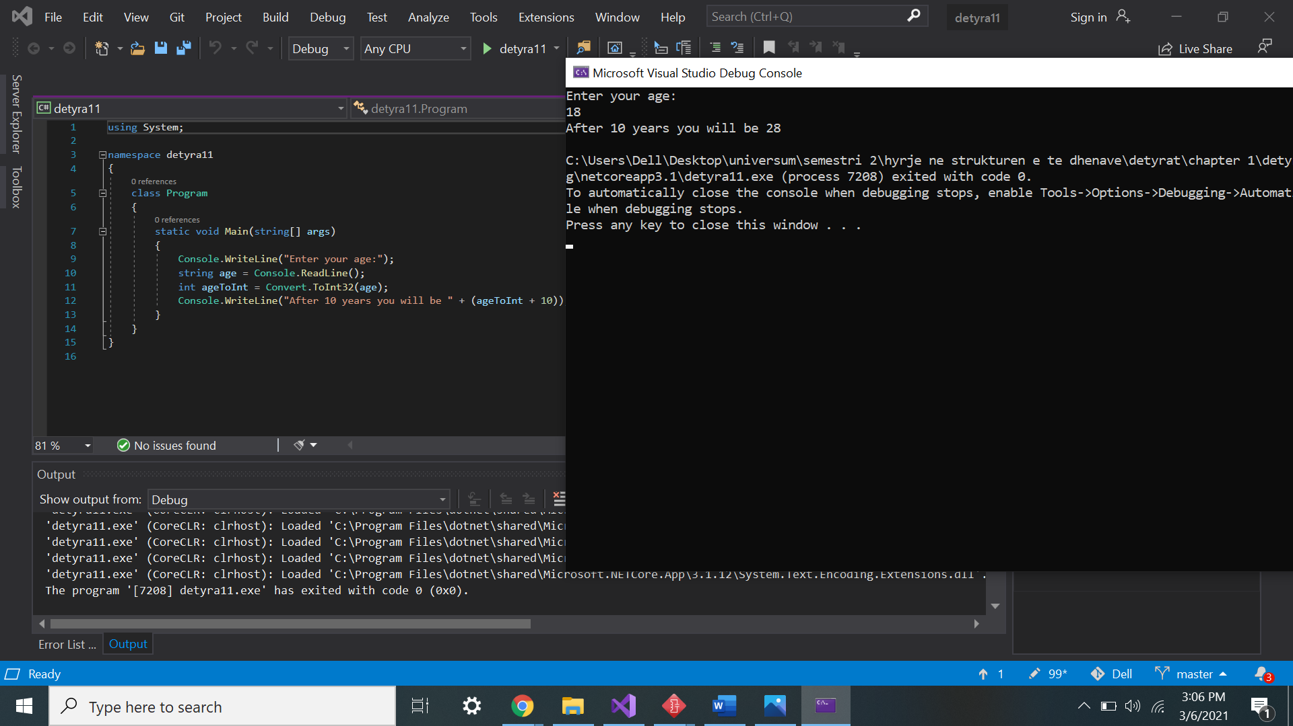

}

}

12.   Describe the difference between **C#** and the **.NET Framework**.

* .NET Framework it is a virtual machine for compiling and executing programs written in different languages like **C#**, VB.Net. It is used to develop Form-based applications, Web-based applications and Web services.
* C# is a modern, type safe programming language, object oriented language that enables programmers to quickly and easily build solutions for the Microsoft. NET platform.

13.   Make a list of the **most popular programming** languages. How are they different from C#?

* Python
* JavaScript
* PHP
* Java
* C#
* C++
* C
* Go
* Swift

Differences from each other:

* It's often used as a “scripting language” for web applications. This means that it can automate specific series of tasks, making it more efficient. Consequently, Python (and languages like it) is often used in software applications, pages within a web browser, the shells of operating systems and some games.
* JavaScript is a text-based programming language used both on the client-side and server-side that allows you to make web pages interactive. Where HTML and CSS are languages that give structure and style to web pages, JavaScript gives web pages interactive elements that engage a user.
* The PHP language is used to design web pages and sometimes it is also used as scripting language. This language is designed to develop a rapid website, and as a result comprises features which make it easy generate HTTP headers and link to databases. As a scripting language, it includes a set of components permit the programmer to easily get up to speed. However, it has more  sophisticated object oriented features.
* Java can be used to create complete applications that may run on a single computer or be distributed among servers and clients in a network. It can also be used to build a small application module or applet (a simply designed, small application) for use as part of a Web page. The Java language is a multi platform language that’s particularly helpful in networking. Of course, mostly this language is used on the web with Java applets. However, this language is used to design cross platform programs, Since it similar to C++ in structure and syntax. For C++ programmers, Java language is very easy to learn and it offers some advantages provided by object oriented  programming. Like reusability and it can be difficult to write efficient code in Java.
* C# is a modern, general-purpose programming language that can be **used** to perform a wide range of tasks and objectives that span over a variety of professions. **C#** is primarily used on the Windows . NET framework, although it can be applied to an open source platform
* The C++ language has an object oriented structure which is used in large projects. Programmers can collaborate one program into different parts or even one individual work on each part of the program. The structure of object oriented also permit code to be reused many times.
* The C language is a basic programming language and it is a very popular language, particularly used in game programming, Because C language includes the additional packing of the C++, Every programmer uses this language because it makes programs faster . However the value of this language gives the reusability of C++ to get the slight increase in performance with C language.
* Go is a really flexible language, able to solve a lot of problems. You can use it for system and network programming, big data, machine learning, audio and video editing, and more.
* Swift is a powerful and intuitive programming language for macOS, iOS, watchOS, tvOS and beyond. Writing Swift code is interactive and fun, the syntax is concise yet expressive, and Swift includes modern features developers love. Swift code is safe by design, yet also produces software that runs lightning-fast

14.   **Decompile** the example program from exercise 5.